**Audio and Video Formats**

There are several varieties of format that a sound or video file can take. Like character encoding, sound and video also requires encoding (to write it) and decoding (to read it) since an analogue signal like a sound wave must be converted to a stream of 1s and 0s.

It would be extremely costly and difficult to **sample** audio and video fully – in fact, logically, it can’t be done since an analogue wave is continuous and digital is discrete. Instead, we have to pick a **sample rate** that is sufficient for the job we want to do.

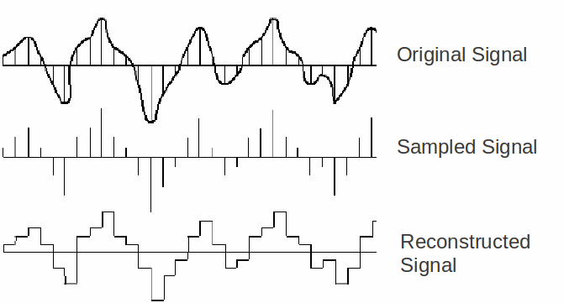

The sample rate is expressed in data storage units – mp3 files, for example, render reasonable audio at 128Kbps (note the small b) which is the same as about 16KB/second, meaning a 4-minute song (240 seconds) can be stored in approximately 3.8MB.

By necessity, converting analogue to digital is a **lossy** process (some information is lost) as compared to a **lossless** process (no information is lost) although these terms are usually used in terms of data compression.

Watch the following video about audio and video codecs to find out more:

<https://www.youtube.com/watch?v=XvoW-bwIeyY>